**Detailed Software Technical Design (DSTD)**

**For**

***<Vyntra Mart>***

**TABLE OF CONTENTS**

**1** **INTRODUCTION 5**

1.1 Purpose 5

1.2 Scope 5

1.3 Definitions, Acronyms and Abbreviations 5

1.4 References 5

**2** **ASSUMPTIONS 6**

**3** **PROJECT OVERVIEW AND USECASE DIAGRAMS 6**

**4** **DETAILED DESIGN FOR MODULE: <<MODULE NAME>> 7**

4.1 Detailed Design for Feature: <<Feature Name>> 7

***4.1.1*** ***User Profile*** *7*

***4.1.2*** ***Navigation Map*** *7*

***4.1.3*** ***UI Screen Design*** *7*

*4.1.3.1* *Screen Layout* 7

*4.1.3.2* *Validations* 8

***4.1.4*** ***Object Model/Data Flow Design*** *8*

*4.1.4.1* *Interface Description* 8

*4.1.4.2* *Class Design* 8

4.1.4.2.1 Algorithmic/Business Logic Description (Optional) 8

4.1.4.2.2 Local Data Structure (Optional) 8

*4.1.4.3* *Data Transfer/Value objects* 8

*4.1.4.4* *Related Database Tables* 9

*4.1.4.5* *Dependencies with Other Sub-systems/Components* 9

4.2 Detailed Design for Feature: <<Feature Name>> 9

**5** **DETAILED DESIGN FOR MODULE: <<MODULE NAME>> 10**

**6** **DATABASE DESIGN 11**

6.1 Entity Relationship Diagrams 11

**7** **PACKAGING/FOLDER STRUCTURE AND SYSTEM ARTIFACTS 12**

7.1 System Artifacts 12

**8** **CORE TECHNICAL SERVICES DESIGN 13**

8.1 Persistence 13

8.2 Inter-process Communication 13

8.3 Authentication and Authorization 13

8.4 Error Handling 13

8.5 Logging 13

8.6 Transaction Management 13

8.7 Other Applicable Technical Services 13

**9** **NON FUNCTIONAL REQUIREMENTS 14**

**APPENDIX 14**

1. Design Metrics to be Used 14

2. Supplementary Information 14

3. DQI – Design Quality Index Checklist 14

**Document Revisions**

|  |  |  |  |  |  |
| --- | --- | --- | --- | --- | --- |
| **Date** | **Version** | **Description** | **Author** | **Reviewer** | **Approver** |
|  |  |  |  |  |  |
|  |  |  |  |  |  |

**Information Handling**

These documents are strictly for **Virtusa/Client** use only. They shall not be shared with an external party other than the client concerned. These documents should always be kept securely and employees shall use reasonable care protecting these documents from unauthorized use or disclosure to a third party. This category also covers client intellectual property where Virtusa has a non-disclosure agreement with the client.

# 

# Introduction

* 1. ***Purpose***

Online shopping helps the customer to shop from home, it saves time and travel for the customer. In this case, the customer had many options and they can compare the different brand quality and price. It sophisticates the customer in many ways. It helps the user to get a qualified product in the market. It helps the vendors to show the product and sell them.

Online shopping helps the customer for easy purchase.

* 1. ***Scope***
* It helps the user to know about the trends in the market since the list has been updated frequently.
* Easy selection of products for the user.
* Highly secure purchase and payment.
* Shopping cart helps to recheck their number of products, quantity.
* It saves the time, fuel and energy of the customer.
* It has 24/7 availability
* It is an instant processing of transaction.
* This system can be implemented to any shop in the locality or to multinational branded shops having retail outlet chains.
  1. ***Definitions, Acronyms and Abbreviations***

**Acronyms:**

ID – Identity number

DBMS- database management System

**Definitions**

User – The customer reviews about the type of products that are being available in the catalog online and purchase the product through payment gateway. Each user has a User ID.

Retailer – Retailer adds the stocks of various kinds of products of different brands using Seller ID.

Administrator – The entire system is being managed by the administrator. It consists of removal of fake vendors.

Payment gateway – This is a kind of zone where the entire purchase payment takes place

Catalog – It is the list that consists of all kinds of products.

* 1. ***References***
* *J Doll. (2011, December 28). Drunk online shopping will save this wretched economy. Village Voice. Retrieved (February 14, 2012) from* [*http://blogs.villagevoice.com/runninscared/2011/12/drunk_online_shopping_trend.php*](http://blogs.villagevoice.com/runninscared/2011/12/drunk_online_shopping_trend.php)
* *K Ehrlich. (2008, July 21). Online Shopping in Today’s Economy. Milstone Insights. Retrieved (February 14, 2012) from* [*http://blog.milestoneinternet.com/education/online-shopping-in-today%E2%80%99s-economy/*](http://blog.milestoneinternet.com/education/online-shopping-in-today%E2%80%99s-economy/)
* *Morah, Chizoba. (2011, July 12). Shopping online: Convenience, bargains, and a few scams. Investopedia.* [*http://www.investopedia.com/articles/pf/08/buy-sell-online.asp#ixzz1msc658Sz*](http://www.investopedia.com/articles/pf/08/buy-sell-online.asp#ixzz1msc658Sz)

* *<http://ijirt.org/master/publishedpaper/IJIRT145617_PAPER.pdf>*

# Assumptions

* *Client/user has an active Internet Connection or has access to one to view the website.*
* *Client runs an operating system which supports internet Browsing.*
* *Our website will not be violating any internet ethnic or cultural rules and won’t be blocked by the telecom companies.*
* *All data entered will be correct and up_to_date.*
* *Users should upload correct payment details and product delivery location.*

# PROJECT OVERVIEW AND USE CASE DIAGRAMS

***Project Overview***

The central concept of the application is to allow the customer to shop virtually using the Internet and allow customers to buy the items and articles of their desire from the store. The information pertaining to the products are stored on a DBMS at the server side . The Server process the customers and the items are shipped to the address submitted by them. The application was designed into two modules first is for the customers who wish to buy the articles. Second is for the storekeepers who maintain and update the information pertaining to the articles and those of the customers. The end user of this product is a departmental store where the application is hosted on the web and the administrator maintains the database. The application which is deployed at the customer database, the details of the items are brought forward from the database for the customer view based on the selection through the menu and the database of all the products are updated at the end of each transaction. Data entry into the application can be done through various screens designed for various levels of users. Once the authorized personnel feed the relevant data into the system, several reports could be generated as per the security.

**UseCase Diagram:**

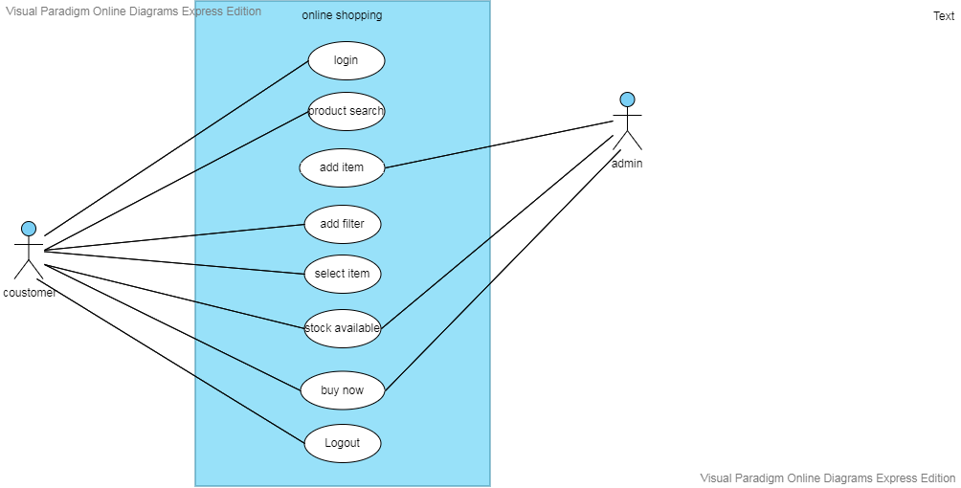

# Detailed Design for Module: <<Vyntra Mart>>

Features used in the design are:

· User-Friendly.

· Mobile-Friendly Website.

· High-Resolution Photos & Video. ...

· User-Generated Reviews. ...

· Special Offers. ...

· Wish Lists. ...

· Find-in-Store. ...

· Related Items

**Sequence Diagram**

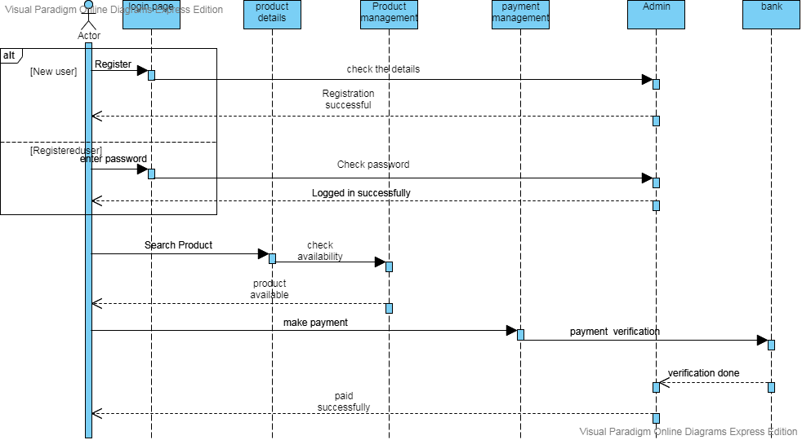

* 1. ***Detailed Design for Feature:***

### **User Profile**

We have multiple users/customers, all can login at a time. Each user had a separate account in the system. The accounts are secured with user-Id and password. This account is connected with the Gmail Google account. The profile contains the wishlist, placed order, tracking the ordered item etc…

### **Navigation Map**

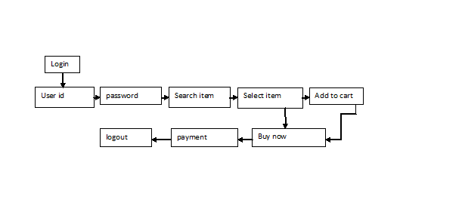

### **UI Screen Design**

|  |  |
| --- | --- |
| **Page Summary** | |
| **Name** | Search for Customer File |
| **Description** | The user retrieves the customer information based on the search criteria such as File ID, last name, first name, middle name, business name, SSN/TIN, address, city, state and/or zip. |
| **Use Case Number** | UC-002 |

#### *Screen Layout*

*[Include a screen shot and describe each element/button in the following table.]*

#### *Validations*

|  |  |  |
| --- | --- | --- |
| **Error Trigger** | **Action** | **Description** |
| If the user group is not selected. | Displays the message “Please select a User Group from the list”. | Prompts the user to select an entry from the User Group list. |
| User enters an invalid date | Displays the message “Enter a valid date. The date must be in <mm-dd-yyyy> format”. | Displays invalid date message. |

### **Object Model/Data Flow Design**

**Flow Chart**

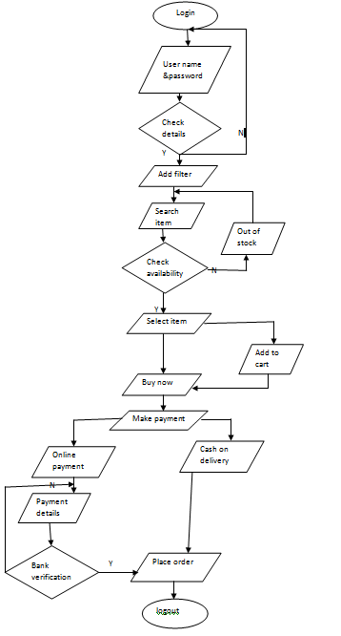

#### *Class Design*

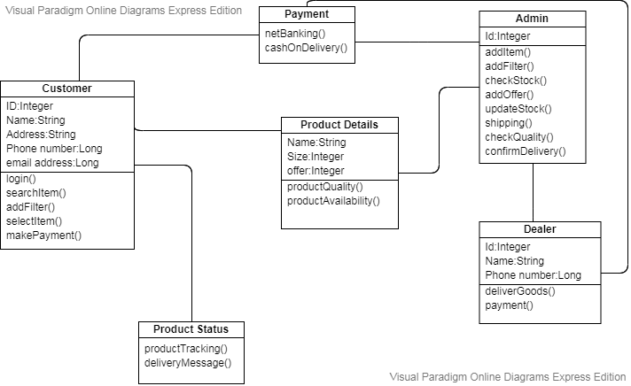

##### Algorithmic/Business Logic Description (Optional)

*[Describe complex algorithms used in the class (if any).]*

##### Local Data Structure (Optional)

*[Describe key data structure algorithms used (if any).]*

#### *Data Transfer/Value objects*

*[Based on the design pattern being used, identify and describe the value/transfer objects.]*

#### *Related Database Tables*

*[Give the list of related database tables.]*

#### *Dependencies with Other Sub-systems/Components*

*[Describe the dependencies with other sub-system/components, if any.]*

* 1. ***Detailed Design for Feature:*** <<Feature Name>>

*Repeat all sub-sections given in 3.1 for this feature.*

# Detailed Design for Module: <<Module Name>>

*[Detailed design for Module 2.]*

*Repeat all sub-sections given in section 3 for this module.*

# Database Design

*[This section describes the persistent data and metadata used and generated by the module/sub-system. This will include database schemas (if the database schema is large, use a separate document for database design), registry structures, property file structures, etc.*

|  |  |
| --- | --- |
| **Models** | **Tools** |
| Database Entity Relationship Diagrams | ERWin |
| Object Models | Rational Rose |

* 1. ***Entity Relationship Diagrams***

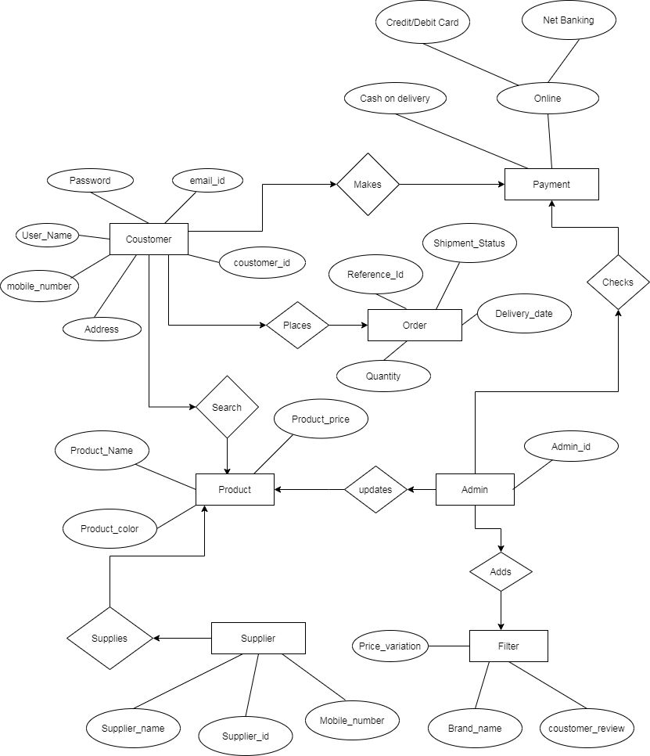

# State Chart Diagram

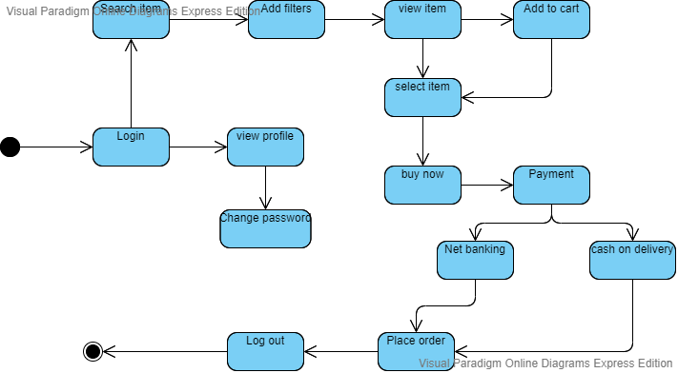

# Packaging/Folder Structure and System Artifacts

*[This section describes the file structure for the <Project Name> project, which will indicate where the code, unit tests, executables, libraries, etc. are to be placed during implementation. Optionally the file structure can be described in a separate GA chapter and a reference given here.]*

**[Sample structure**

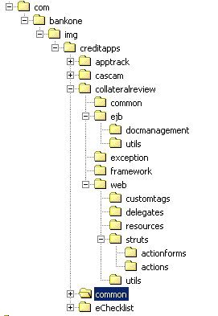

**End Sample Structure]**

* 1. ***System Artifacts***

*[Provide information on the Registry structure, INI files, property files, configuration files, etc.]*

# Core Technical Services Design

*[This section describes the detailed design and usage pattern for the core technical services of the system.]*

* 1. ***Persistence***

*[This sub-section captures the detailed design and usage patterns of the persistence service for the application.]*

* 1. ***Inter-process Communication***

*[This sub-section captures the detailed design and usage patterns of the inter-process communication framework for the application.]*

* 1. ***Authentication and Authorization***

*[This sub-section captures the detailed design and usage patterns of the security services for the application.]*

* 1. ***Error Handling***

*This sub-section captures the detailed design and usage patterns of the error handling services for the application.]*

* 1. ***Logging***

*[This sub-section captures the detailed design and usage patterns of the logging framework for the application.]*

* 1. ***Transaction Management***

*[This sub-section captures the detailed design and usage patterns of the Transaction Management service for the application.]*

* 1. ***Other Applicable Technical Services***

*[This sub-section captures the detailed design and usage patterns of the other core technical services to be handled by the system such as* *the* *installation mechanism, failure prevention, fault tolerance, caching design, internationalization, validation framework, client and server initialization, error handling, etc.]*

# 9 Non Functional Requirements

# Appendix

*[Presents information that supplements the design specification.]*

1. ***Design Metrics to be Used***

*[A description of all design metrics to be used during the design activity is listed here.]*

1. ***Supplementary Information***

*[Provide as required.]*

1. ***DQI – Design Quality Index Checklist***

This checklist shall be used to perform self-review as a reference while preparing software design.

**